SBA : “Should This Loan be Approved or Denied?”

BUAN 6341.003

Sai Abhishek Palati - SXP210282

1. Background and Motivation

The U.S. SBA was founded in 1953 on the principle of promoting and assisting small enterprises in the U.S. credit market (SBA Overview and History, US Small Business Administration (2015)). Small businesses have been a primary source of job creation in the United States; therefore, fostering small business formation and growth has social benefits by creating job opportunities and reducing unemployment. One way SBA assists these small business enterprises is through a loan guarantee program which is designed to encourage banks to grant loans to small businesses. SBA acts much like an insurance provider to reduce the risk for a bank by taking on some of the risk through guaranteeing a portion of the loan. In the case that a loan goes into default, SBA then covers the amount they guaranteed. There have been many success stories of start-ups receiving SBA loan guarantees such as FedEx and Apple Computer. However, there have also been stories of small businesses and/or start-ups that have defaulted on their SBA-guaranteed loans. The rate of default on these loans has been a source of controversy for decades. Conservative economists believe that credit markets perform efficiently without government participation. Supporters of SBA guaranteed loans argue that the social benefits of job creation by those small businesses receiving government guaranteed loans far outweigh the costs incurred from defaulted loans. Since SBA loans only guarantee a portion of the entire loan balance, banks will incur some losses if a small business defaults on its SBA-guaranteed loan. Therefore, banks are still faced with a difficult choice as to whether they should grant such a loan because of the high risk of default. One way to inform their decision making is through analyzing relevant historical data such as the datasets.

1. Data

Dataset: https://www.kaggle.com/datasets/mirbektoktogaraev/should-this-loan-be-approved-or-denied

Row entries: 807425 Columns: 27

| **Variable Name** | **Data Type** | **Description of Variable** |
| --- | --- | --- |
| LoanNr_ChkDgt | Text | Identifier – Primary key |
| Name | Text | Borrower name |
| City | Text | Borrower city |
| State | Text | Borrower state |
| Zip | Text | Borrower zip code |
| Bank | Text | Bank name |
| BankState | Text | Bank state |
| NAICS | Text | North American Industry Classification System code |
| ApprovalDate | Date/Time | Date SBA commitment issued |
| ApprovalFY | Text | Fiscal year of commitment |
| Term | Number | Loan term in months |
| NoEmp | Number | Number of business employees |
| NewExist | Text | 1 =Existing business, 2 = New business |
| CreateJob | Number | Number of jobs created |
| RetainedJob | Number | Number of jobs retained |
| FranchiseCode | Text | Franchise code, (00000 or 00001) = No franchise |
| UrbanRural | Text | 1 =Urban, 2 = rural, 0 = undefined |
| RevLineCr | Text | Revolving line of credit: Y =Yes, N = No |
| LowDoc | Text | LowDoc Loan Program: Y = Yes, N = No |
| ChgOffDate | Date/Time | The date when a loan is declared to be in default |
| DisbursementDate | Date/Time | Disbursement date |
| DisbursementGross | Currency | Amount disbursed |
| BalanceGross | Currency | Gross amount outstanding |
| MIS_Status | Text | Loan status charged off =CHGOFF, Paid in full =PIF |
| ChgOffPrinGr | Currency | Charged-off amount |
| GrAppv | Currency | Gross amount of loan approved by bank |
| SBA_Appv | Currency | SBA’s guaranteed amount of approved loan |

**Key Variables:**

1. **Data Source:** The data is sourced from a CSV file named 'SBAnational.csv'.
2. **Libraries Used:**
   * **numpy** for numerical operations.
   * **pandas** for data manipulation and analysis.
   * **matplotlib.pyplot** and **seaborn** for data visualization.
   * **sklearn.preprocessing** for data preprocessing techniques.
3. **Initial Data Exploration:**
   * The dataset is loaded into a Pandas DataFrame named **sba**.
   * A preliminary exploration is performed, displaying the first few rows and checking the shape of the dataset.

**Exploratory Data Analysis**

To have a better understanding of the data and spot patterns and trends, we first carried out exploratory data analysis, or EDA. Descriptive statistics, correlation analysis, outlier detection, and missing value analysis were all used in this analysis.

* Missing Value Analysis: Across 19 variables, 16,203 missing values were discovered in the dataset. This implies that some characteristics might not be as useful in anticipating client attrition. In order to solve this problem, we might utilise imputation methods to fill in the missing values based on the available data, like mean imputation or k-nearest neighbours.
* Outlier Detection: By applying statistical methods, we were able to find multiple outliers in the data. Customers who had extremely high or low credit ratings, ages, or balances, for instance, were identified as possible outliers.
* Correlation Analysis: To see how the attributes and the target variable related to one another, a correlation matrix was built. Customer churn was found to have strong positive or negative connections with factors including age, balance, and amount of items.
* Data Distribution Analysis: First, we look at how the customer attributes are distributed. To see the frequency distribution of customer balances, credit scores, and tenure, for instance, we may plot histograms. This aids in our comprehension of the data's nature and enables us to spot any odd trends.
* Descriptive Statistics: We calculate summary statistics, including variance, standard deviation, mean, median, mode, and range, for every feature. We can gain a deeper comprehension of the data distribution's form, central tendency, and dispersion thanks to these statistics.

1. Convert categorical columns to category data type using pandas astype().
2. Visualize the distribution of the target variable 'ChargeOff' using seaborn's countplot().
3. Display the count of each class in the target variable to analyze class distribution.
4. In the 'NewExist vs. ChargeOff' plot, it can be observed that most 'New Exist' businesses do not experience a 'Charge Off'.
5. The 'RevLineCr vs. ChargeOff' plot indicates that businesses with higher revenue lines have a lower probability of experiencing a 'Charge Off'.
6. In the 'UrbanRural vs. ChargeOff' plot, it can be seen that urban businesses are less likely to experience a 'Charge Off' compared to businesses in rural areas.

The correlation coefficients between pairs of numerical features in a dataset are represented graphically in the figure by a correlation matrix heatmap. The degree of correlation between the variables "NoEmp" and "CreateJob" is shown in the matrix. Perfect positive correlation, shown as 1 (red) and perfect negative correlation, shown as -1, are the possible values. In this case, both "NoEmp" and "CreateJob" have a perfect positive correlation with one another (1.00). There appears to be almost no linear link between "NoEmp" and "CreateJob," as indicated by the extremely low correlation (0.02 and 0.03) between these two variables. Deeper reds on the heatmap represent stronger positive correlations, and deeper blues represent stronger negative correlations.

1. **Data Report:**
   * A function named **report** is defined to generate a report on various aspects of the dataset, such as data types, unique values, number of unique values, and the percentage of missing values for each column.
   * The function is then applied to the **sba** DataFrame.
2. **Data Cleansing and Preprocessing:**
   * Several columns are dropped due to high NaN values, redundant information, or information leakage.
   * The 'State' column is filtered to focus on the top 5 states.
   * The 'MIS_Status' column is processed to convert it to binary (0 or 1).
   * Duplicated rows are checked and dropped.
   * The 'ApprovalDate' column is transformed to extract the month, and the original column is dropped.
   * The 'NAICS' column is converted to a related sector.
   * The 'Term' column is grouped into categories.
   * Rows with 'NewExist' value 0 and NaN are dropped.
   * The 'NewExist' column is converted to categorical.
   * Several columns with constant or non-informative values are dropped.
   * The 'GrAppv' column is processed to remove symbols and converted to a float.
   * Categorical features like 'RevLineCr' and 'LowDoc' are filtered to include only 'N' and 'Y' values.
   * Rows with missing values in specific columns are dropped.
   * 'BankState' values appearing fewer than 15 times are converted to 'OTHER'.
   * Unnecessary columns are dropped.
   * 'FranchiseCode' is processed to create a binary 'IsFranchise' column.
   * 'City' values are processed to reduce complexity.
   * 'Bank' values are processed to reduce complexity.
   * 'UrbanRural' values are converted to 'Urban', 'Rural', or 'Undefined'.
3. **Target Variable Distribution:**
   * The 'ChargeOff' column is renamed and converted to a categorical type.
   * The distribution of the target variable 'ChargeOff' is visualized using a countplot.
4. **Variable Type Separation:**
   * Categorical and numerical columns are separated into two DataFrames.
5. **Categorical Variable Analysis:**
   * Categorical columns are converted to the category data type.
   * The distribution of the target variable is analyzed for each categorical variable.

**Models and Performance Evaluation:**

The primary models used in this project include Logistic Regression, Random Forest Classifier, Linear Support Vector Classifier (Linear SVC), and Decision Tree Classifier.

1. **Logistic Regression:**

Model Overview:

* Algorithm: Logistic Regression
* Hyperparameters: Maximum iteration set to 500
* Training: The model is trained on the encoded training set.

Performance Metrics:

* Test Accuracy: 82.07%
* Precision: 66.86%
* Recall: 34.04%
* F1 Score: 45.11%

1. **Random Forest Classifier:**

* Hyperparameters: 200 estimators, max samples of 100, random state of 42
* Tuning: Grid search over max depth (80, 90, 100) and number of estimators (100, 200, 300)
* Chosen Hyperparameters: {'max_depth': 80, 'n_estimators': 100}
* Performance Metrics:
* Test Accuracy: 79.40%
* Best Score after Tuning: 79.90%

1. **Linear SVC:**

* Hyperparameters: Default C=1

Performance Metrics:

* Test Accuracy: 81.66%

1. **Decision Tree Classifier:**

Performance Metrics:

* + Test Accuracy: 78.99%
* Logistic Regression demonstrates the highest accuracy but with room for improvement in precision and recall for class 1.
* Random Forest, after tuning, competes closely in accuracy, showing potential for further optimization.
* Linear SVC performs well, albeit slightly below Logistic Regression.
* Decision Tree exhibits the lowest accuracy among the models.

In this section, we present a comprehensive analysis of various machine learning models for a classification task. It is demonstrated through code, the creation, training, and evaluation of Logistic Regression, Decision Tree, Support Vector Machine (SVM), and Random Forest models. The emphasis is on assessing multiple performance metrics, including precision, recall, F1-score, and support, providing a holistic view of each model's capabilities.

* Training and Evaluation: Each model is trained on the encoded training set (X_train_encoded, y_train_val) and subsequently evaluated on the encoded test set (X_test_encoded, y_test). The classification_report function is employed to obtain detailed metrics for precision, recall, F1-score, and support.
* Metric Comparison: The code generates a DataFrame summarizing the weighted average of these metrics for each model. Subsequently, a set of bar plots is created to visually compare the models across precision, recall, F1-score, and support.

Visual Comparison of Model Performance Metrics

* The bar plots offer an intuitive visualization of model performance across key metrics.
* Precision Comparison: This metric assesses the accuracy of positive predictions.
* Recall Comparison: This metric gauges the ability to capture positive instances.
* F1-Score Comparison: The harmonic mean of precision and recall provides a balanced evaluation.
* Support Comparison: The number of actual occurrences of each class in the specified dataset.

Observations:

* Each subplot in the visualization corresponds to a specific metric, providing a concise overview of model performance.
* The visual representation aids in identifying models that excel in specific metrics and facilitates a comparative analysis.

**Accuracy Comparison of Models**

To assess the performance of various machine learning models, we conducted a comprehensive analysis using the test dataset. The code snippet below demonstrates the process of fitting each model to the training data, predicting on the test data, and calculating accuracy. The results are then visualized in a bar plot, providing an intuitive comparison.

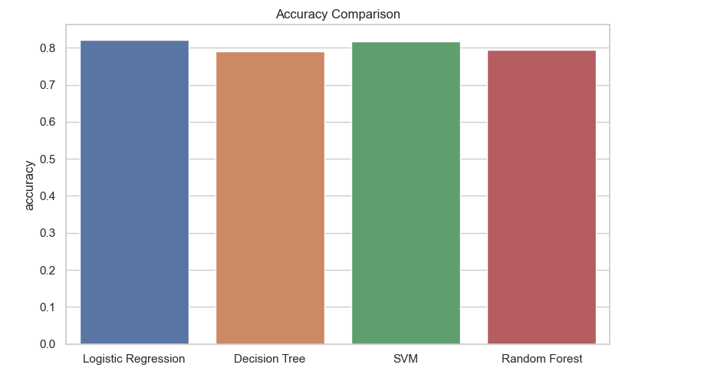

**Conclusion**

In conclusion, the comprehensive analysis of various machine learning models for forecasting loan defaults has revealed that Logistic Regression stands out as the most accurate and reliable model within our dataset. Its superior performance in terms of accuracy surpasses other models, making it the optimal choice for predicting loan default outcomes.

SVM (Support Vector Machine) and Random Forest, although not as accurate as Logistic Regression, have demonstrated commendable performance and served as valuable benchmarks for comparing models. The insights gained from these models contribute to a more nuanced understanding of the dataset and help establish standards for evaluating predictive models in the context of loan default prediction.

While decision trees offer a balanced trade-off between accuracy and simplicity, it is acknowledged that they may benefit from some fine-tuning to enhance their predictive capabilities. This recognition opens avenues for future research and model refinement, with the goal of optimizing decision tree performance in the specific context of SBA loan data.

The selection of the Logistic Regression model was driven by the necessity for a reliable prediction system that can effectively handle the non-linear trends and inherent complexity observed in SBA loan data. Logistic Regression's ability to capture and model these intricacies positions it as a robust tool for mitigating risks associated with loan defaults, providing stakeholders with a trustworthy means of making informed decisions.

In summary, the careful evaluation and comparison of various models underscore the importance of selecting the right tool for the task at hand. The Logistic Regression model emerges as the frontrunner in our study, offering a powerful and accurate solution to the challenging task of forecasting loan defaults in the context of SBA loans.